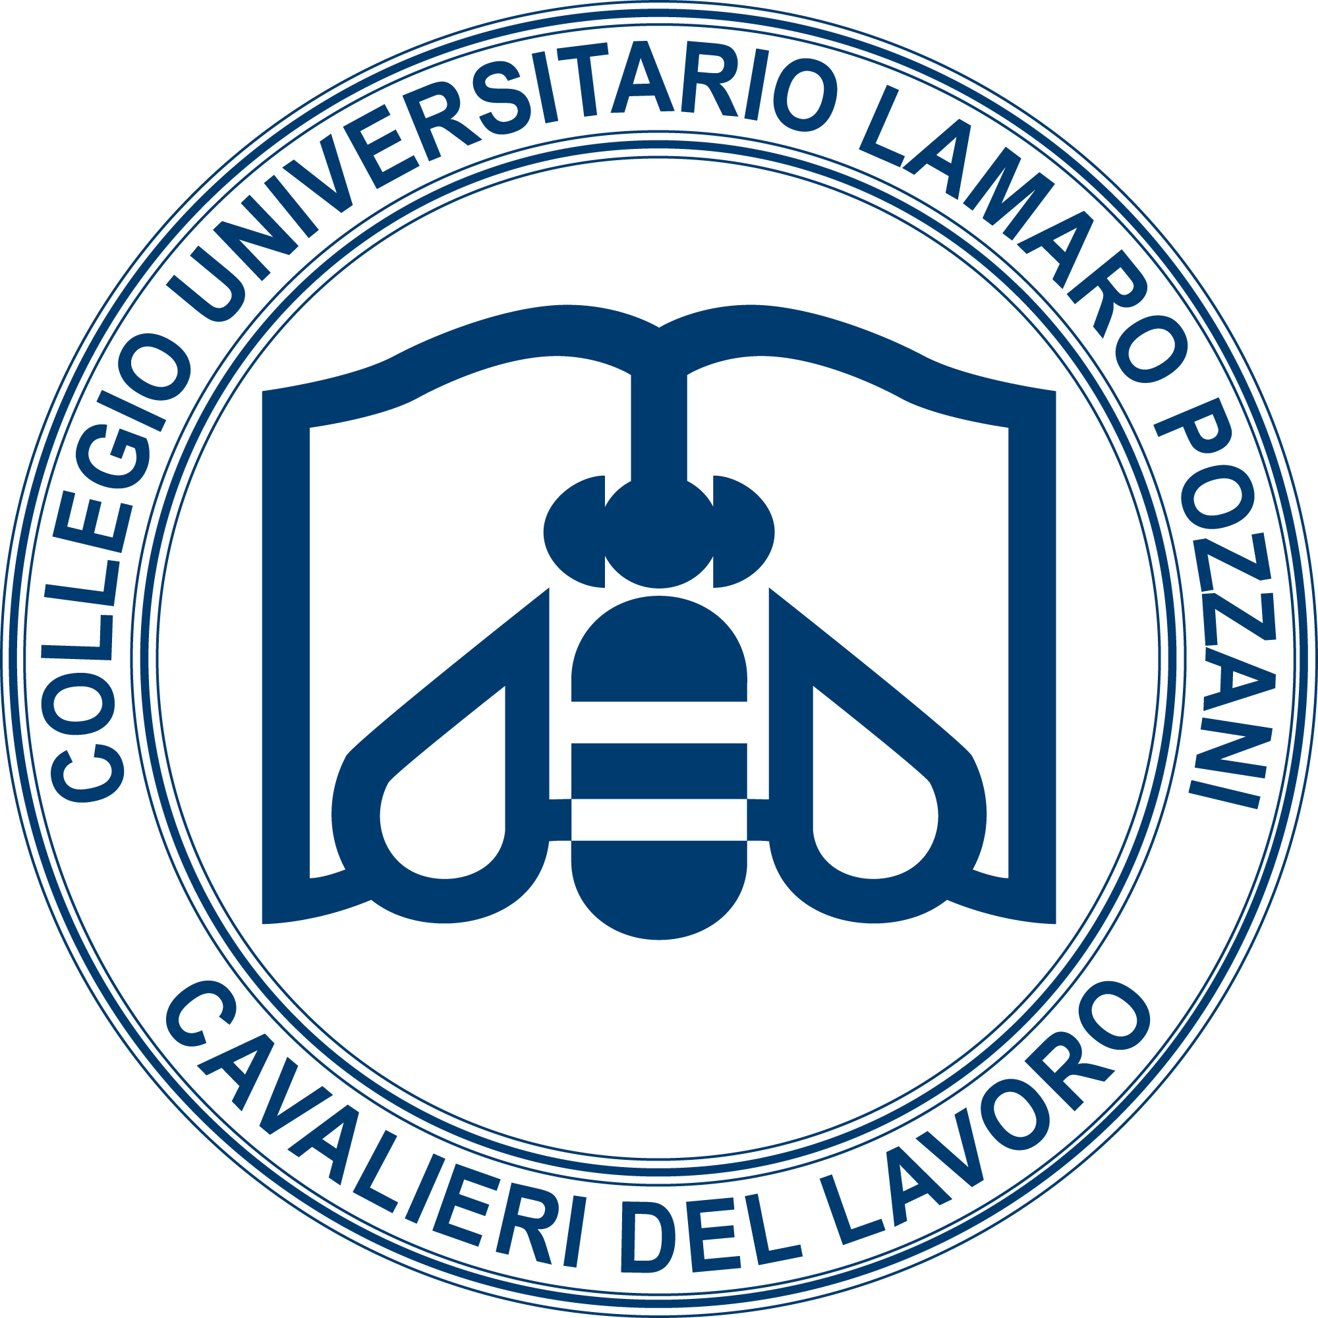

Application form
Personal details
First name
Second name
Date and place of birth
Nationality
Country of residence
Email address

Other information
University where you are registered
Subject of doctorate
Year of doctoral studies (first, second...)
Visiting students only: at which Rome university will you be carrying out your research, how long for and why have you decided to carry out research overseas?
Declaration of level of English (may be verified by means of an online interview)
Please describe in no more than five lines the type of seminar you intend to deliver to the College’s students (the subject, method, etc.)
For how many months do you wish to live in the College?

Please attach your academic CV/résumé (max. 5 pages)

